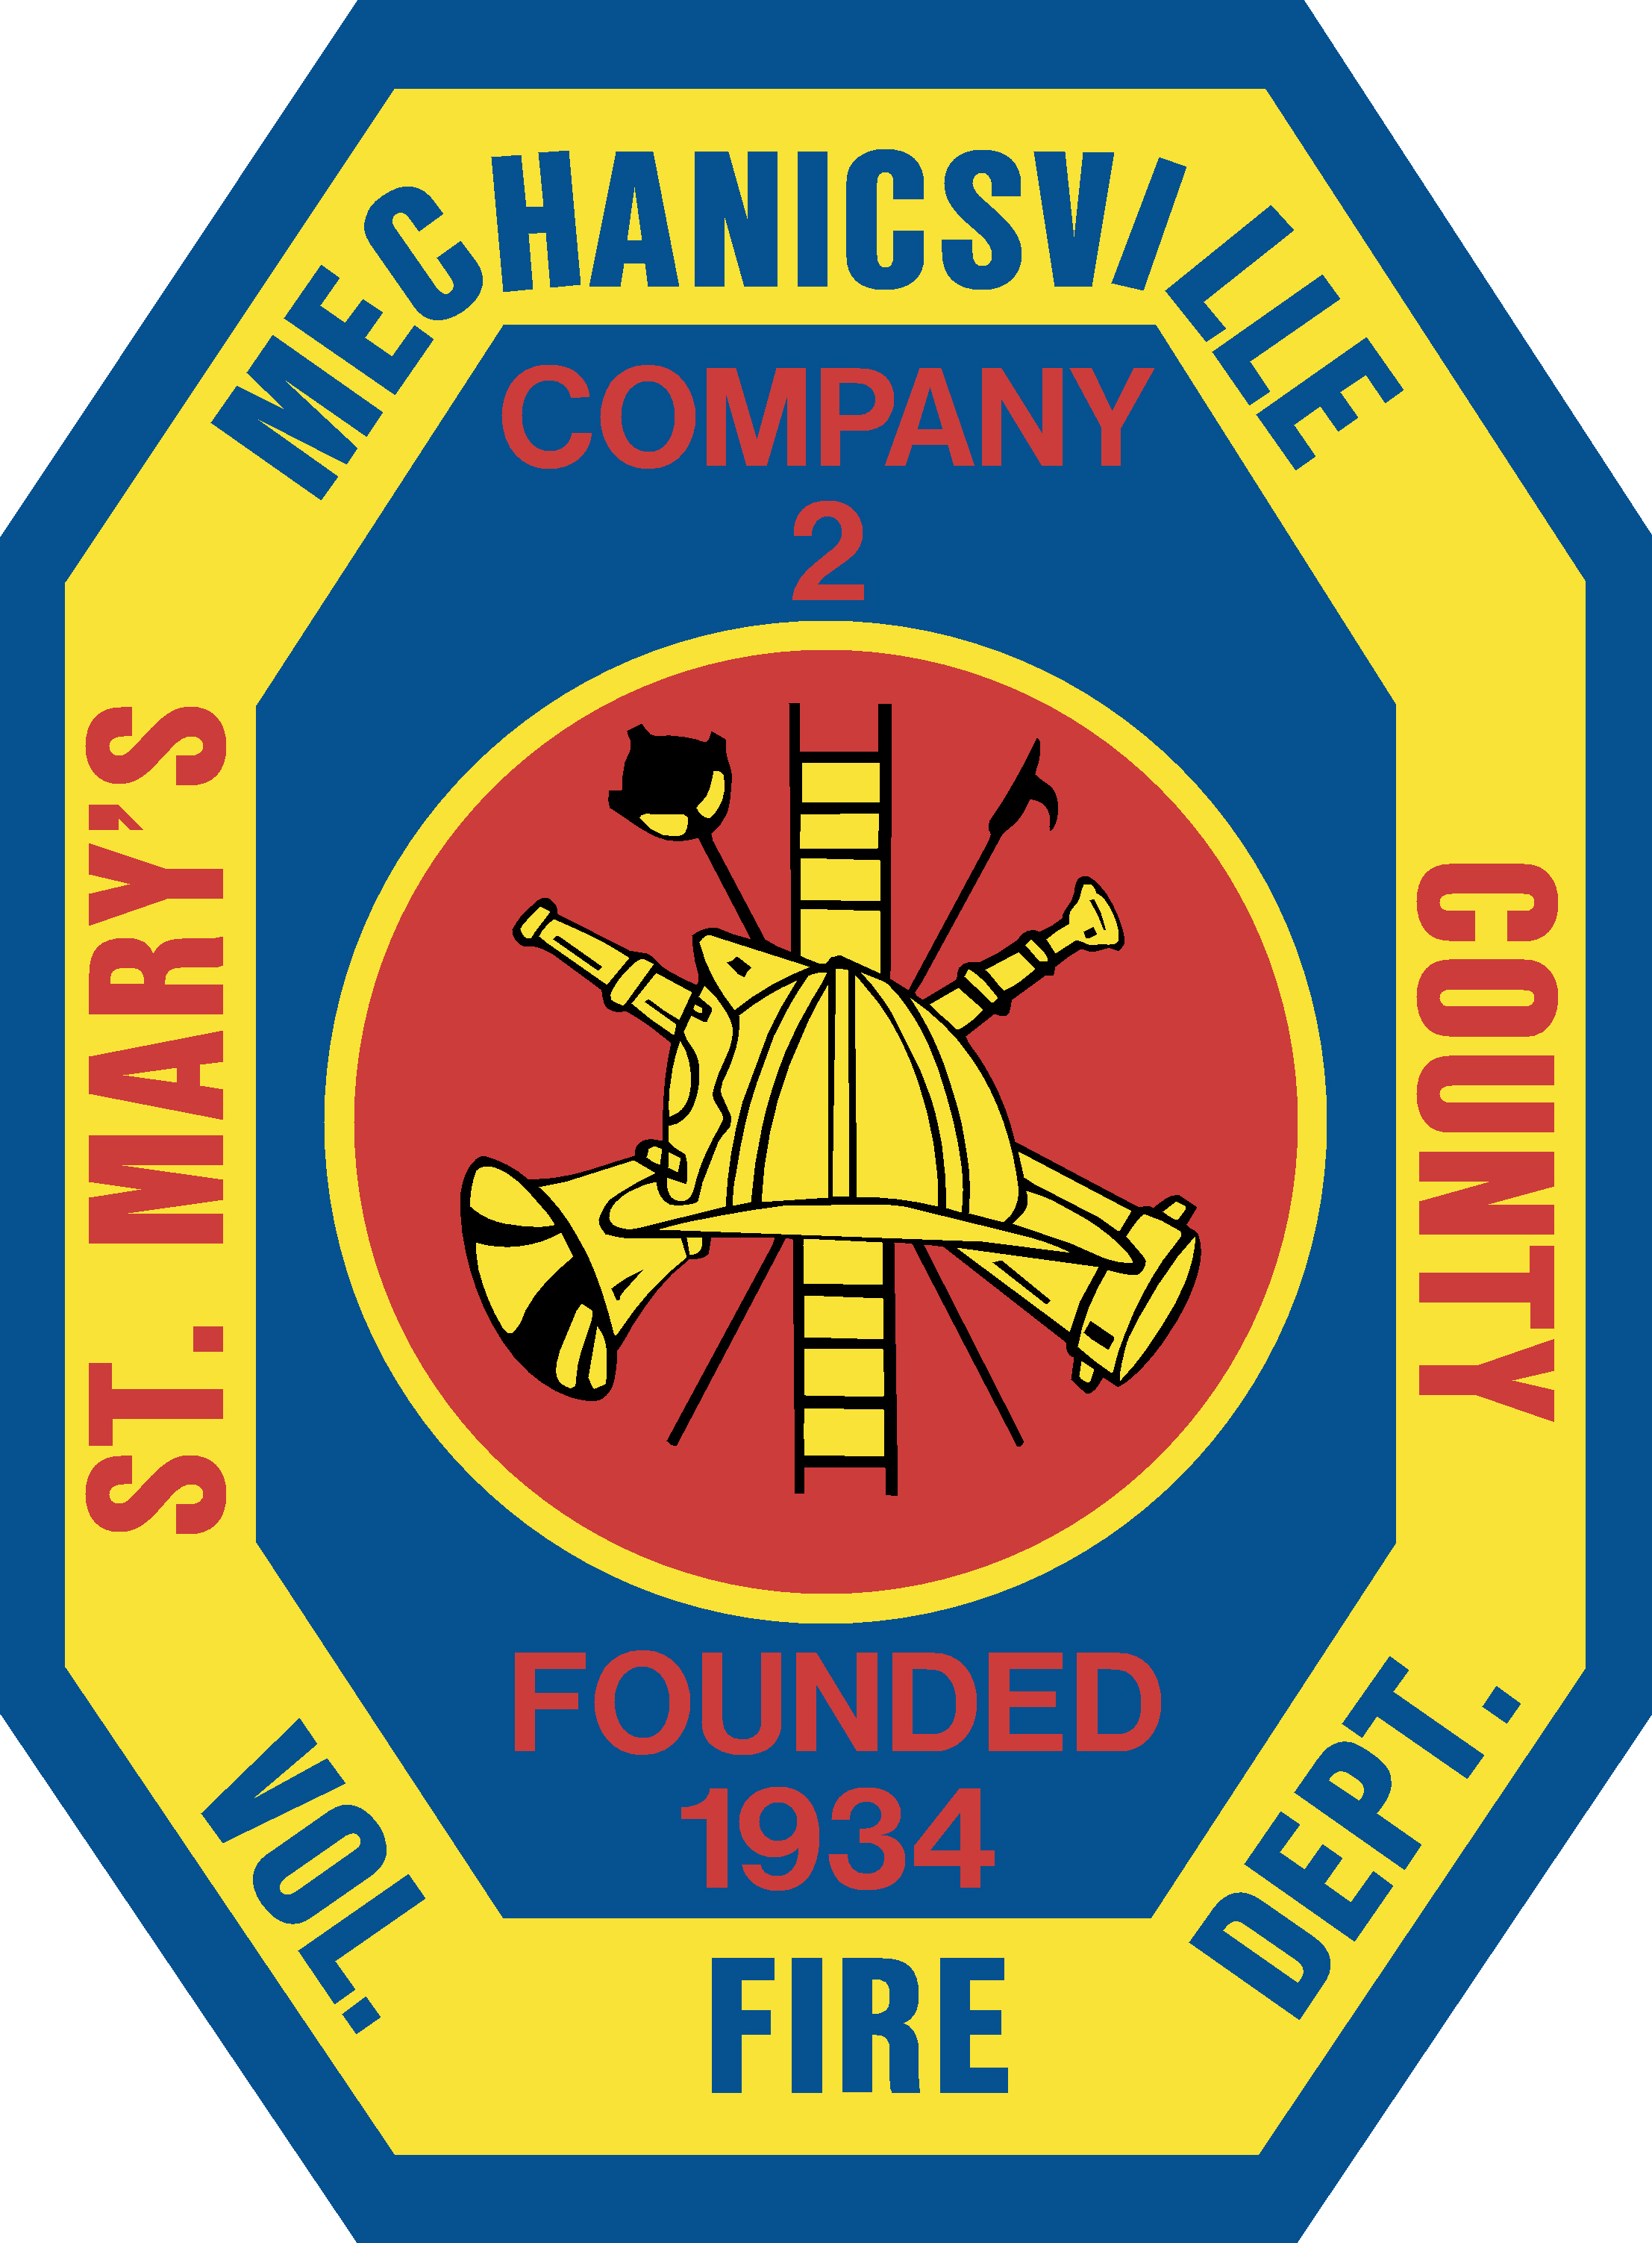 | Mechanicsville Volunteer Fire Department, Inc.  Post Office Box 37  Mechanicsville, MD 20659  Non Emergency: (301) 884-4709 / Emergency: Dial 9-1-1  www.mvfd.com

December 13, 2021

To: Jason Topper, Fire & Rescue Products
Ron Carr, Municipal Emergency Services, Inc.
Bryan Wilson, Atlantic Emergency Services
Sam Pearce, Chesapeake Fire & Rescue Equipment, Inc.

Subject: Rescue Tool Selection Process

First and foremost, I would like to thank all of you for your time, efforts, support, and information provided to our department. Your input and knowledge has assisted us in the difficult task of selecting a brand and line-up of rescue tools to upgrade our current inventory, which will allow us to continue providing the best care to the communities we serve.

We stated from the start of this evaluation we would be transparent to all vendors and provide any feedback we could to each of you. It is our intention that the info provided will hopefully assist each of you in providing valuable feedback to your respectable manufacturer. With that, below is a list all of the pros and cons compiled from the feedback our membership provided. They are listed by tool manufacturer and a summarization of our decision is noted at the end.

- Amkus
  - Pros
    - Very durable tool
    - Option for a 40” Spreader
    - Cutter was able to cut the Subaru Post
    - 24-hour response time for issues
  - Cons
    - Non-Proprietary battery
    - Tools are heavy
    - Cutter opening is small
    - Not Waterproof
    - Battery had to be replaced at the end of the demo due to dying

- Genesis
  - Pros
    - Rotating Handle for use
    - Composite Handle to help prevent electrocution
    - Battery pack for use in extended operations
    - Was able to cut Subaru Post
  - Cons
    - Non-Proprietary Battery
    - Bad Battery location
    - Thumb control not user friendly to most
    - Tool cuts off quickly when not in use
    - Battery had to be replaced at the end due to dying

- Holmatro
  - Pros
    - Handle designed for use all the way around the tool
    - Lights are placed all the way around the tool in the handle
    - Battery Charger has the capability to charge the second battery in the tool and gives the tool the priority charge. The cord to the tool is also fireman friendly as it’s magnetic and no clips are involved.
    - Incline Cutter option
    - Proprietary Battery
    - Waterproof
    - Cutter was able to cut Subaru Post
    - Tool has audible notification at maximum pressure (assists in daily checks and when operating)
    - 24-hour response time for issues
    - Interlocking Eye-Bolt design allows cutter to reach into tight areas just a bit further than conventional bolt on cutters
  - Cons
    - Spreader Tips can potentially cause the door to “peel” due to aggressiveness

- Hurst
  - Pros
    - Proprietary Battery
    - 2 hours of run time
    - Waterproof
    - 10-year warranty
    - Tool has audible notification at maximum pressure (assists in daily checks and when operating)
    - 24-hour response time for issues
    - Specific battery designed just for saltwater use
  - Cons
    - Cutter was the slowest to cut the Subaru Post, and took several attempts
    - Slowest operating tool
    - Thumb control wasn’t the most friendly
    - Battery location was difficult to get to when cutting a relief cut to roll the dash and the battery died.

We went into this evaluation after responding to an incident where our current cache of tools did not perform as needed. We were able to obtain one of the “B” posts out of the vehicle we were unable to cut and use it for our evaluations. Being able to cut thru this post was the center point in our process.

We met six times as a department holding round table discussions and conducting hands on tool evaluations. Each time we met, we compiled information, progressing towards making a decision. All of the manufacturers that were evaluated were great and would be a major step-forward for the inventory of our current equipment and would have increased our capabilities.

After final review and discussion, the Department has selected Holmatro Rescue Tools. They met and exceeded all our requirements and expectations.

In closing, the Mechanicsville Volunteer Fire Department would like to again thank all of you for the time, assistance, knowledge and contributions afforded to us during this process. We appreciate the opportunity to use and evaluate your products, and to ensure that we are doing our jobs of protecting the visitors and citizens of Mechanicsville. We hope that you find our feedback useful in any further evaluations and improvements as you move forward.

Committed to your safety,
Ryan Raley
Deputy Fire Chief

